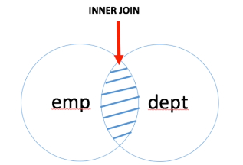
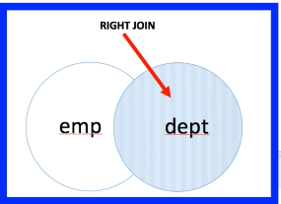

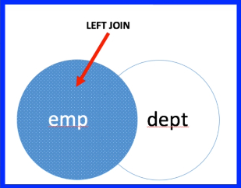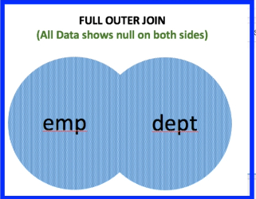

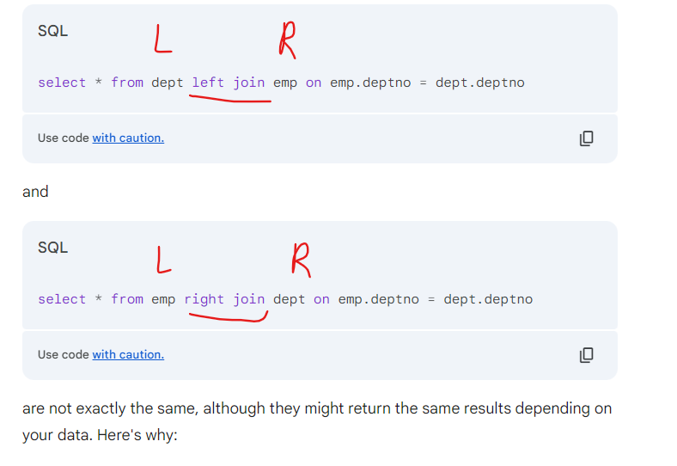

SELF JOIN
select e.ename employee, m.ename manager
from emp e, emp m
where e.mgr = m.empno;

select e.ename employee, m.ename manager
from emp e left join emp m
on e.mgr = m.empno;

select * from emp;

